A Liturgy for Ukraine – and Peace.
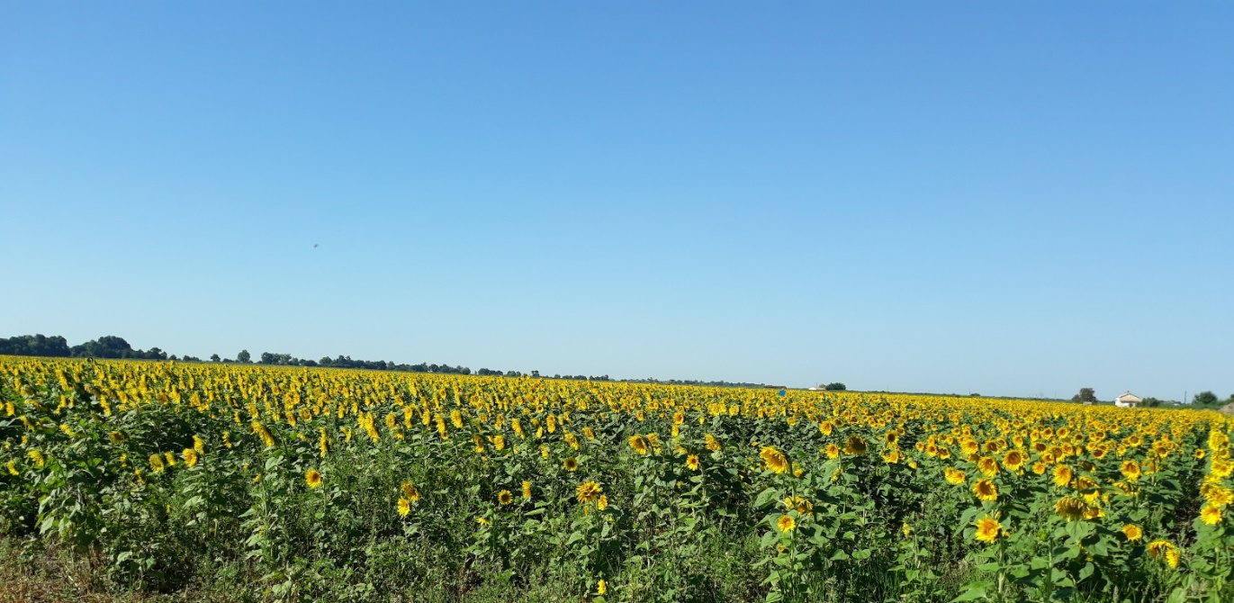
Focal point – if needed
Sky-blue cloth, candle (Paschal Candle if you have one), Bible, packs of sunflower seeds, silk sunflowers or photos.

Opening Responses

Reader | We gather in the name of the Father:  Who created the sun to give light and warmth to the children of the earth.
All | But, Father, that light is veiled by the clouds of war:  The dust of bombings;  The darkness of fear;  The fogs of lies and confusion:  And the children of your earth are afraid.
Reader | We gather in the name of the Son:  The one who rose with a new dawn for humanity.
All | And yet, Lord Jesus –  Where does the light of your resurrection shine  in a world filled with death and destruction?  Lord Jesus, we yearn for the lights of peace and of hope.
Reader | We gather in the name of the Holy Spirit:  Whose gifts are wisdom and knowledge,  right judgement and fortitude,  understanding and fear of the Lord
All | But, Spirit of God,  The gifts you pour out with such grace and generosity  are squandered and abused  by those who use them to make war on innocence.  Blessed Spirit, shine the light of your gifts into the cold hearts of men –  Kindle in them the fire of your love for all peoples.
Scripture | There are many passages that would be useful. Below is a selection.  Depending on the group, one idea might be to choose a sentence from several of them to create a kind of scripture mosaic. Invite people in the group to read them in turn with a pause between them.  Isaiah 2: 4; Isaiah 9: 2b - 7; Psalm 46; James 3: 13-18; Revelation 21: 1-5, 23-26; Matthew. 11: 25-30; John 14: 27
Music | If in-person, this is probably best chosen from your own repertoire.  If online, try:  - Kyrie Eleyson- Ukrainian Orthodox Chant of the XV Century by Kyiv Chamber Choir (sacred choral music)  - The Jesus Prayer in Ukrainian  - Taizé - Gospodi Pomiluj (Ukrainian)  - Russian/Ukrainian Kyrie (chant with verses)
Intercessions | Invite people to make their own intercessions for things close to their hearts.  Or simple intentions – for example:  - The people of Ukraine – those who have died; those who have been wounded or traumatised; those who have fled into exile.  - The peoples of Eastern Europe – welcoming strangers while living with intense fear for their own futures.  - The people of Russia – those who bravely protest against the war; those conscripted to fight; those making decisions costing so many innocent lives.  - Those suffering war and its consequences throughout our world.
Simple ritual | Sunflower seeds  The national flower of Ukraine is the sunflower. From the small seed, a great plant can grow. Its flower blooms like the sun. Fields of sunflowers glow in the summer sun. In the harvest, the seeds offer oil to humans and food for creatures in the winter.  Our seeds represent the seeds of our hope – for peace – for light – for justice – for mercy – for all that God offers abundantly to his world.  We sow our seeds in hope that the sun again will rise in power, peace and joy over Europe.
Closing Responses
Reader | Creator God, you gave the sun for our light and our warmth:
All | May your children again know the light of your love  and the warmth of your healing.
Reader | Lord, Jesus, you are the Morning Star that heralds a new dawn.
All | O Morning Star,  splendour of light eternal and sun of righteousness:  Come and enlighten those who dwell in darkness  and the shadow of death.
Reader | Blessed Spirit, come upon us and the whole of our world –  Especially upon our sisters and brothers in Ukraine.
All | May we see again the fruits of your labouring among us:  the fruits of love and joy,  peace and, patience,  kindness and generosity,  faithfulness, gentleness and self-control.
Reader | And may all who are suffering warfare and exile  be this day under light of God’s blessing.
All | Amen
If in the evening, you might like to close with this prayer from St Augustine:

Watch now, dear Lord,
with those who wake or watch or weep tonight;
and give your angels charge
over those who sleep.
Tend your wounded ones, O Christ;
rest your weary ones,
bless your dying ones,
soothe your suffering ones,
shield your joyous ones
and all for your love's sake.
Amen

