Week 3 – Mary

A reading from Schripture

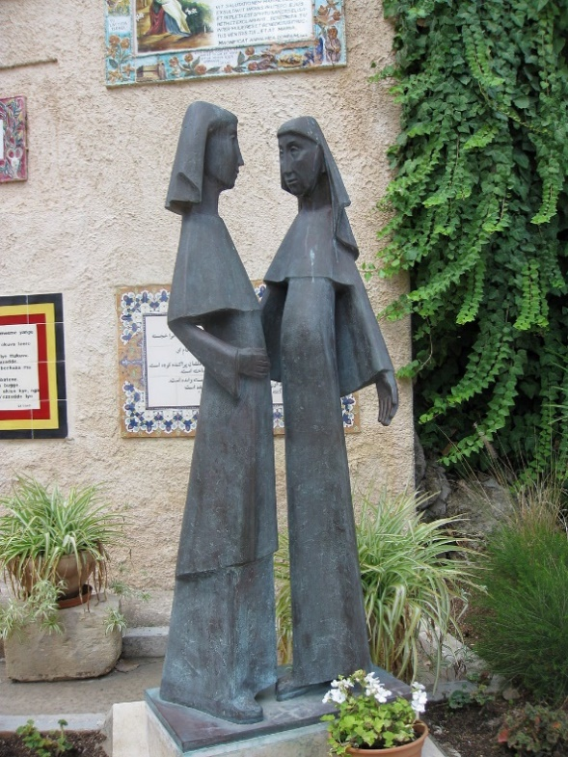
Mary said,
‘My soul magnifies the Lord,
and my spirit rejoices in God my Saviour,
for he has looked with favour on the lowliness of his servant.
Surely, from now on all generations will call me blessed;
for the Mighty One has done great things for me,
and holy is his name.
His mercy is for those who fear him
from generation to generation.
He has shown strength with his arm;
he has scattered the proud in the thoughts of their hearts.
He has brought down the powerful from their thrones,
and lifted up the lowly;
he has filled the hungry with good things,
and sent the rich away empty.
He has helped his servant Israel,
in remembrance of his mercy,
according to the promise he made to our ancestors,
to Abraham and to his descendants for ever.’
From Luke 1: 39-56

About Mary

Mary is honoured by Christians for her unique role in God’s plan of salvation. As a chief character, she seems a rather strange choice. This is the God who, after all, chose patriarchs like Abraham – and raised up great prophets like Moses, Isaiah, Jeremiah – and mighty kings like David and Solomon. But, for the final stage, he chose a young woman in a small village from which, someone would later say, nothing good could ever come!
We know nothing of the early years of this young woman until the moment an angel appeared telling her that she would conceive and bear a son who would be the Son of the Most High. She is confused and wonders what it could possibly mean, but comes to trust the message and agrees to work with God and let what has been promised happen. It is easy to romanticise this moment, but her decision was to lead Mary into situations of stress and deep distress. There was great joy – but also great suffering.
She was, above all, a woman of hope and trust. In the face of all that was to happen, she was steadfast in faith. She offers us a model of discipleship that is not afraid to see and acknowledge the pain in the world but knows that this is not the end – that God’s promise of justice and peace is still valid and that we are invited to work with God to bring it to fulfilment.

Pause for thought

Our world is in a particularly troubled time. We are still in the grip of the Covid-19 pandemic which is causing thousands of deaths, many more severe illnesses – as well as loss, bereavement, fear and isolation. Alongside this, we see increased hunger as donations to charity reduce. We see people abusing their power – people already rich exploiting the grave situation facing our planet for their own financial benefit.
Like Mary, we may look at all of this and, at first, wonder where God is in it all. We can, though, like her trust God – and ourselves. The commission placed on the shoulders of a 14-year old from Nazareth was to work with God in a way that no-one would ever do again – but that work has not ended. God calls us to work to end hunger – to bring justice and peace – to trust in God’s promise and to work with God to bring it to fulfilment.

Symbol of hope

If you made an Advent Wreath, light the first and second candle. As you prepare to light the third candle, think about Mary and her cousin Elizabeth – and the seeds of life sown in them that were to bear such fruit. You may like to buy a packet of seeds and, at the appropriate time, sow them as a sign of belief in God’s ability to bring new life out things that seem dead and unpromising.
If you do not have a wreath, simply light a candle.
Pray using your own words – or these if they are helpful:
We bless you, our God of all generations.
We bless you, Christ, who came into the world as an embryo – a foetus – a new-born.
We bless you, Holy Spirit, who came upon Mary at Jesus’ conception –
and who comes upon us, making us Christ-bearers in a troubled world.
Be with us God of all ages:
give us grace and courage to work with you
so that the promises you make each day and everyday
are brought to the fulfilment you desire.
Amen

