Advent 2021 – Theme of Hope.
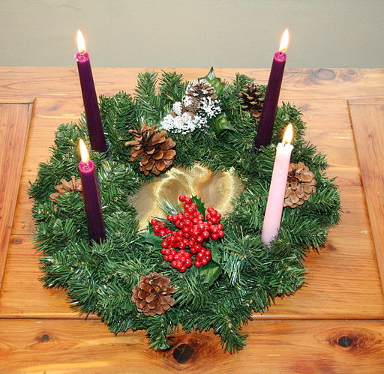
Create an Advent focus.
Jonathunder, CC BY-SA 3.0 via Wikimedia Commons
This could be an advent wreath – which can be as simple or as complicated as you like. Instructions for making one are here https://www.youtube.com/watch?v=iq9mzyjfKvQ (with links to others) but they are also available to buy in different styles. For safety, you may prefer to use electric candles – these are not quite the same but you do not have to remember to blow them out!
Take a photo and share it with SDE and/ or post on CCC: https://www.facebook.com/groups/267518617576684

Week 1 – Isaiah

A Reading from Scripture
Isaiah writes:  The Lord said to me:  They will pass through the land, greatly distressed and hungry; when they are hungry, they will be enraged and will curse their king and their gods. They will turn their faces upwards, or they will look to the earth, but will see only distress and darkness, the gloom of anguish; and they will be thrust into thick darkness.  But there will be no gloom for those who were in anguish. In the former time he brought into contempt the land of Zebulun and the land of Naphtali, but in the latter time he will make glorious the way of the sea, the land beyond the Jordan, Galilee of the nations.  The people who walked in darkness  have seen a great light;  those who lived in a land of deep darkness—  on them light has shined.  You have multiplied the nation,  you have increased its joy;  they rejoice before you  as with joy at the harvest,  as people exult when dividing plunder.  For the yoke of their burden,  and the bar across their shoulders,  the rod of their oppressor,  you have broken as on the day of Midian.  For all the boots of the tramping warriors  and all the garments rolled in blood  shall be burned as fuel for the fire.  For a child has been born for us,  a son given to us;  authority rests upon his shoulders;  and he is named  Wonderful Counsellor, Mighty God,  Everlasting Father, Prince of Peace.  Isaiah 8:21- 9: 7(NRSV) | 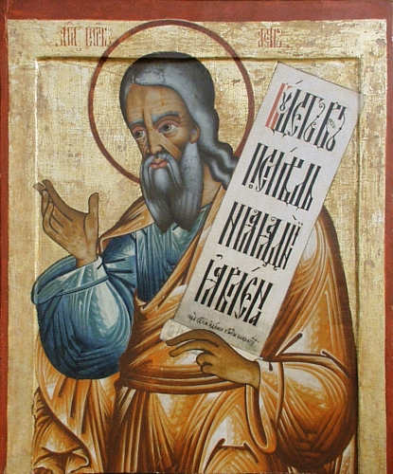

About Isaiah
Isaiah is often seen as the prophet of Advent and Christmas because he was the one who spoke most often of the coming of the Messiah. He lived in 8th-century BC and seems to have prophesied during the reigns of four kings – although it is now believed that the Book we know as Isaiah was actually three “books” with the first 39 chapters written by Isaiah himself and the remainder written by his disciples immediately before and after the end of the exile in Babylon, almost two hundred years later.
The themes in all sections of the Book of Isaiah rest on God’s plan for his people. The people deserted God, but God did not ever abandon them. They suffered the consequences of their disobedience, but their punishment would purify them and teach them their need of God. In the darkest days of their Exile when God’s people thought they would never be restored to their homeland, Isaiah foretold a second exodus when the remnant who had remained faithful would be blessed and return to their lands.
Isaiah writes of God sending his messenger up to a high mountain and proclaim the good news (Is 40:9). A mountain is where people often encounter God and is also the place where, in the darkest part of the night, the first glimmering of a new dawn is visible on the horizon – a light that is not – yet - visible to those in the valley. It is this voice that proclaims to those living through the dark days of winter and of the Covid pandemic: “Do not fear – here is your God!”

Pause for thought
In the northern hemisphere, there is a deep darkness. The sun is low in the sky – if the sun appears at all – and the darkest days are yet to come. It is as if the time of year echoes how many people feel all around the world. They feel the oppression of darkness – of fear – of loneliness – of death and bereavement – and more… As people look ahead to Christmas, the darkness can feel even deeper … But we open our Advent retreat with words from Isaiah.
He was writing at a dark time for the People of God when hope was hard to find but, in the face of all the suffering and despair, Isaiah kept pointing people’s hearts to the coming of God’s promise – to come among his people – to be in all the pain of the world with them.
We are people who know and live in the fulfilment of that promise. We are called to people who bring the light of hope into our world today.

Symbol of hope
If you made an Advent Wreath, turn out the lights and think of all the people who are oppressed by darkness and despair. Then light the first candle. Notice how that one small light is stronger than the darkness – the light is not overcome.
If you do not have a wreath, simply light a candle..
Pray using your own words – or these if they are helpful:
We bless you, our God who created light.
We bless you, Christ, the Light who came into the world.
We bless you, Holy Spirit, who kindles the flame of hope in human hearts.
Be with us in these dark days,
Give us courage and strength to bring your light and hope to the people we will meet this week.
In Jesus’ name.
Amen

